# How to Access Workday:

Step 1: From The Can, click on the Workday icon (insert screenshot here)

Step 2: Choose if you have company email, no company email, or are NW Container or River Rock employees.

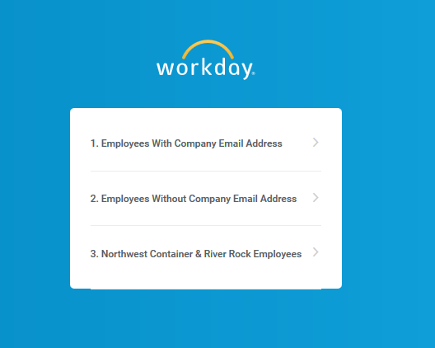

Step 3: Enter your clock number as your user name and your temp password assigned to you.

